**EXPERIMENT 1**

**AIM :To study various cables used in computer communication. (Patch cables, Ethernet crossover cables,USB cable,Unshielded Twisted Pair (UTP) Cable , Shielded Twisted Pair (STP), Coaxial Cable, Fibre optic Cable)**

**THEORY:**

The cables used in computer communication are as follows:

1. Patch Cables:

A patch cable is a general term for cabling that connects two electronic devices to each other, typically in a network. These devices might include computers and other hardware. Patch cables are also used to carry telephone, audio, and video signals between devices in non-networked applications; these might include equipment such as headphones and microphones.

Patch cables are also called patch leads. The term patch cord is sometimes used as well, but it's often associated more with non-network types of cables such as those for wiring stereo components.

Patch cables are different from other types in that they're made to be more flexible than standard stiff, bulky copper cables. Patch cables always have connectors at both ends.

A [crossover cable](https://www.lifewire.com/crossover-cable-ethernet-817870) is a specific type of Ethernet patch cable used to connect two computers to each other.

Non-networking patch cables might include headphone extension cables, microphone cables, RCA connectors, XLR connectors, TRS phone connector cables, Tiny Telephone connectors, patch panel cables, etc. They also can be thick "snake cables" that transmit video and amplified signals.

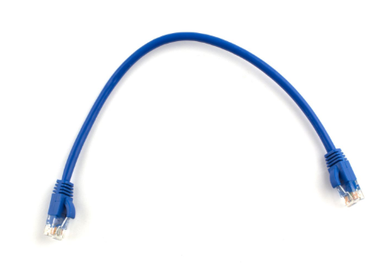

1. Ethernet Crossover Cable:

An Ethernet crossover cable is a network cable used to connect two Ethernet network devices directly such as two computers without a switch or router in between. They are used to send and receive data by enabling complex data transfers between computers, routers, and networks. Ethernet crossover cables are similar to straight-through cable except that they have pairs of wires that crisscross. Their internal wiring reverses the incoming and outgoing signals and uses a design that allows the data output pins on one end of the cable to be connected directly to the data input pins on the other end of the cable.

Crossover cables are used when:

* Connecting a computer to a computer
* Connecting a router to a router
* Connecting a switch to a switch
* Connecting a hub to a hub and
* Connecting a router to a PC because both devices have the same components.

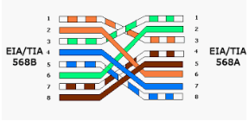

1. USB Cable:

The term [USB](http://www.l-com.com/search.aspx?q='USB'&join=All&cmp=LPUSB) stands for **"Universal Serial Bus"**.  [USB cable assemblies](http://www.l-com.com/category.aspx?id=3006&cmp=LPUSB) are some of the most popular cable types available, **used mostly to connect computers to peripheral devices** such as cameras, camcorders, printers, scanners, and more. Devices manufactured to the current USB Revision 3.0 specification are backward compatible with version 1.1.  
 The USB cable standard allows for these advantages over serial cable types:

* USB cables are **"Hot Pluggable"**, in other words you can connect and disconnect the cables while the computer is running without fear of freezing the computer
* USB cables are **fast**, transferring up to 480Mbps.  Compare that to serial communication which transfers data at about 20Kbps
* USB cables **carry power** as well as signals.  This allows for "USB powered" gadgets as well as recharging batteries in cameras and other USB peripherals
* USB cables are designed with **several distinct connector types**, making it easy to identify which plug goes into the computer and which plug goes into the peripheral device
* USB cables are a **universal standard** and are fairly easy to find and to afford

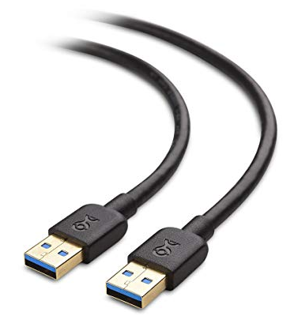

1. Unshielded Twisted Pair(UTP) Cable:

UTP stands for Unshielded Twisted Pair cable. UTP cable is a 100 ohm copper cable that consists of 2 to 1800 unshielded twisted pairs surrounded by an outer jacket. They have no metallic shield. This makes the cable small in diameter but unprotected against electrical interference. The twist helps to improve its immunity to electrical noise and EMI.UTP cables were invented for voice applications. Voice UTP cables only needed to carry analog signals which are very robust and not easily corrupted by electrical noise or EMI. However, as UTP cables were used for different systems, higher quality UTP cables were required to support data systems that used digital signaling.

As the applications evolved, different categories or grades of UTP cables were created  along these years. Higher category UTP cables are referred to as data grade UTP cables, and low category UTP cables are referred to as voice grade UTP cable

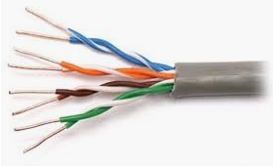

1. Shielded Twisted Pair Cable(STP):

Often abbreviated STP, a type of copper telephone wiring in which each of the two copper wires that are twisted together are coated with an insulating coating that functions as a ground for the wires. The extra covering in shielded twisted pair wiring protects the transmission line from [electromagnetic interference](https://www.webopedia.com/TERM/E/EMI.html) leaking into or out of the cable. STP cabling often is used in [Ethernet](https://www.webopedia.com/TERM/E/Ethernet.html)networks, especially fast data rate Ethernets.

Shielded twisted pair (STP) cable was originally designed by IBM for token ring networks that include two individual wires covered with a foil shielding, which prevents electromagnetic interference, thereby transporting data faster.  
STP is similar to unshielded twisted pair (UTP); however, it contains an extra foil wrapping or copper braid jacket to help shield the cable signals from interference. STP cables are costlier when compared to UTP, but has the advantage of being capable of supporting higher transmission rates across longer distances.

* Frequency
* Thickness
* Type of electromagnetic noise field
* Distance from the shield to the noise source
* Shield discontinuity
* Grounding practices

Some STP cablings make use of a thick copper braided shield which makes the cable thicker, heavier, and in turn much more difficult for installation as compared to the UTP cables.

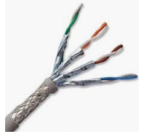

1. Fibre Optic Cable:

An optical fiber cable is a type of cable that has a number of optical fibers bundled together, which are normally covered in their individual protective plastic covers. Optical cables are used to transfer digital data signals in the form of light up to distances of hundreds of miles with higher throughput rates than those achievable via electrical communication cables. All optical fibers use a core of hair-like transparent silicon covered with less refractive indexed cladding to avoid light leakage to the surroundings. Due to the extreme sensitivity of the optical fiber, it is normally covered with a high-strength, lightweight protective material like Kevlar.  
  
Optical fiber cable is widely used in fiber optic communications.wo common types of fiber optics are:

* Single-mode fiber (SMF)
* Multi-mode fiber (MMF)

Interconnection between multiple fiber strands is much more complex and difficult to achieve, than the ones between electrical cables.

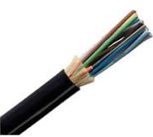

**EXPERIMENT 2**

**AIM : To make a comparative study of various motherboards. (Intel 80386,Intel 80486, Pentium Processor , Pentium Pro, Pentium II , Celeron, Pentium III etc..)**

**THEORY:**

The motherboards are as follows:

1. Intel 80386:

Intel 80386 also known as (386 and i386) is the third-generation [Intel](https://whatis.techtarget.com/definition/Intel) [x86](https://searchwindowsserver.techtarget.com/definition/x86) microprocessor introduced in October 1985. The 386 followed Intel’s 8086 and [80286](https://whatis.techtarget.com/definition/Intel-80286) processors and predated the [80486](https://whatis.techtarget.com/definition/Intel-80486).The 80386 was capable of 11 million instructions per second (MIPS) and featured:

* [Protected mode](https://searchstorage.techtarget.com/definition/protected-mode) capabilities.
* 32-bit [registers](https://whatis.techtarget.com/definition/register) and instruction set.
* A [paging](https://whatis.techtarget.com/definition/paging) translation unit for better [virtual memory](https://searchstorage.techtarget.com/definition/virtual-memory) support.
* Speeds from 12Mhz to 40Mhz.
* Increased memory support, to 4GB.

The 80386 was also released in subsequent versions including the 386SX, a lower cost version lacking a math coprocessor. 386SL is the low-power version intended for mobile computers.Some 386 processors had a bug that could cause a lock-up when running in a 32-bit environment. It was very hard for an end user to determine whether the problem was a software bug or a hardware flaw. To address the issue, Intel created a certified testing program whereby chips found to be error free were marked with a double sigma.

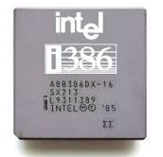

1. Pentium Processor:

**Pentium**, Family of [microprocessors](https://www.britannica.com/technology/microprocessor) developed by [Intel Corp](https://www.britannica.com/topic/Intel). Introduced in 1993 as the successor to Intel’s 80486 [microprocessor](https://www.britannica.com/technology/microprocessor), the Pentium contained two processors on a single [chip](https://www.britannica.com/technology/integrated-circuit) and about 3.3 million [transistors](https://www.britannica.com/technology/transistor). Using a CISC (complex instruction set computer) architecture, its main features were a 32-[bit](https://www.britannica.com/technology/bit-communications) address bus, a 64-bit data bus, built-in floating-point and memory-management units, and two 8KB [caches](https://www.merriam-webster.com/dictionary/caches). It was available with processor speeds ranging from 60 megahertz (MHz) to 200 MHz. The Pentium quickly became the processor of choice for personal computers. It was superseded by ever faster and more powerful processors, the Pentium Pro (1995), the Pentium II (1997), the Pentium III (1999), and the Pentium 4 (2000).

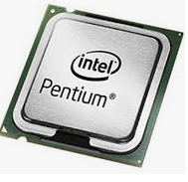

1. Pentium Pro:

The Pentium Pro is a sixth-generation [x86](https://en.wikipedia.org/wiki/X86" \o "X86) [microprocessor](https://en.wikipedia.org/wiki/Microprocessor" \o "Microprocessor) developed and manufactured by [Intel](https://en.wikipedia.org/wiki/Intel" \o "Intel) introduced in 1 November 1995. It introduced the [P6 microarchitecture](https://en.wikipedia.org/wiki/P6_(microarchitecture)" \o "P6 (microarchitecture)) (sometimes referred to as i686) and was originally intended to replace the original [Pentium](https://en.wikipedia.org/wiki/P5_(microarchitecture)" \o "P5 (microarchitecture)) in a full range of applications. While the Pentium and Pentium MMX had 3.1 and 4.5 million [transistors](https://en.wikipedia.org/wiki/Transistor" \o "Transistor), respectively, the Pentium Pro contained 5.5 million transistors. Later, it was reduced to a more narrow role as a server and high-end desktop processor and was used in [supercomputers](https://en.wikipedia.org/wiki/Supercomputer" \o "Supercomputer) like [ASCI Red](https://en.wikipedia.org/wiki/ASCI_Red" \o "ASCI Red), the first computer to reach the [teraFLOPS](https://en.wikipedia.org/wiki/TeraFLOPS" \o "TeraFLOPS) performance mark. The Pentium Pro was capable of both dual- and quad-processor configurations. It only came in one form factor, the relatively large rectangular [Socket 8](https://en.wikipedia.org/wiki/Socket_8" \o "Socket 8). The Pentium Pro was succeeded by the [Pentium II Xeon](https://en.wikipedia.org/wiki/Pentium_II_Xeon" \o "Pentium II Xeon) in 1998.

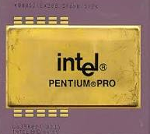

1. Pentium II:

The Pentium II brand refers to [Intel](https://en.wikipedia.org/wiki/Intel" \o "Intel)'s sixth-generation [microarchitecture](https://en.wikipedia.org/wiki/Microarchitecture" \o "Microarchitecture) ("[P6](https://en.wikipedia.org/wiki/P6_(microarchitecture)" \o "P6 (microarchitecture))") and [x86](https://en.wikipedia.org/wiki/X86" \o "X86)-compatible [microprocessors](https://en.wikipedia.org/wiki/Microprocessor" \o "Microprocessor) introduced on May 7, 1997. Containing 7.5 million [transistors](https://en.wikipedia.org/wiki/Transistor" \o "Transistor) (27.4 million in the case of the mobile Dixon with 256 [KB](https://en.wikipedia.org/wiki/Kilobyte" \o "Kilobyte) [L2 cache](https://en.wikipedia.org/wiki/CPU_Cache" \o "CPU Cache)), the Pentium II featured an improved version of the first *P6*-generation core of the [Pentium Pro](https://en.wikipedia.org/wiki/Pentium_Pro" \o "Pentium Pro), which contained 5.5 million transistors. However, its L2 cache subsystem was a downgrade when compared to the Pentium Pro's.

In 1998, Intel stratified the Pentium II family by releasing the Pentium II-based [Celeron](https://en.wikipedia.org/wiki/Celeron" \o "Celeron) line of processors for low-end workstations and the [Pentium II Xeon](https://en.wikipedia.org/wiki/Pentium_II_Xeon" \o "Pentium II Xeon) line for servers and high-end workstations. The Celeron was characterized by a reduced or omitted (in some cases present but disabled) on-die full-speed L2 cache and a 66 MT/s FSB. The Xeon was characterized by a range of full-speed L2 cache (from 512 KB to 2048 KB), a 100 MT/s FSB, a different physical interface ([Slot 2](https://en.wikipedia.org/wiki/Slot_2" \o "Slot 2)), and support for [symmetric multiprocessing](https://en.wikipedia.org/wiki/Symmetric_multiprocessing" \o "Symmetric multiprocessing). In February 1999, the Pentium II was replaced by the nearly identical [Pentium III](https://en.wikipedia.org/wiki/Pentium_III" \o "Pentium III), which only added the then new [SSE](https://en.wikipedia.org/wiki/Streaming_SIMD_Extensions" \o "Streaming SIMD Extensions) instruction set.

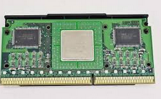

1. Celeron:

Celeron is a [brand name](https://en.wikipedia.org/wiki/Brand_name" \o "Brand name) given by [Intel](https://en.wikipedia.org/wiki/Intel" \o "Intel) to a number of different low-end [IA-32](https://en.wikipedia.org/wiki/IA-32" \o "IA-32) and [x86-64](https://en.wikipedia.org/wiki/X86-64" \o "X86-64) computer [microprocessor](https://en.wikipedia.org/wiki/Microprocessor" \o "Microprocessor) models targeted at low-cost personal computers.

Celeron processors are compatible with [IA-32](https://en.wikipedia.org/wiki/IA-32" \o "IA-32) computer programs, but their performance is typically significantly lower when compared to similar CPUs with higher-priced Intel CPU brands. The Celeron brand will often have less [cache](https://en.wikipedia.org/wiki/CPU_cache" \o "CPU cache) memory, or have advanced features intentionally disabled. These missing features can have a variable impact on performance, but is often very substantial. While a few of the Celeron designs have achieved surprising performance, most of the Celeron line has exhibited noticeably degraded performance. This has been the primary justification for the higher cost of other Intel CPU brands versus the Celeron range.

Introduced in April 1998, the first Celeron branded CPU was based on the [Pentium II](https://en.wikipedia.org/wiki/Pentium_II" \o "Pentium II). Subsequent Celeron branded CPUs were based on the [Pentium III](https://en.wikipedia.org/wiki/Pentium_III" \o "Pentium III), [Pentium 4](https://en.wikipedia.org/wiki/Pentium_4" \o "Pentium 4), [Pentium M](https://en.wikipedia.org/wiki/Pentium_M" \o "Pentium M), and [Intel Core](https://en.wikipedia.org/wiki/Intel_Core" \o "Intel Core). The latest Celeron design (as of January 2017) is based on the seventh generation Core i3/i5/i7 series ([Kaby Lake](https://en.wikipedia.org/wiki/Kaby_Lake_(microarchitecture)" \o "Kaby Lake (microarchitecture))).[[2]](https://en.wikipedia.org/wiki/Celeron" \l "cite_note-2) This design features independent processing cores (CPUs), but with only 66% as much cache memory as the comparable Core i3 offering.

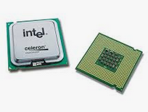

1. Pentium III:

The Pentium III (marketed as Intel Pentium III Processor, informally PIII) brand refers to [Intel](https://en.wikipedia.org/wiki/Intel" \o "Intel)'s [32-bit](https://en.wikipedia.org/wiki/32-bit" \o "32-bit) [x86](https://en.wikipedia.org/wiki/X86" \o "X86) desktop and mobile [microprocessors](https://en.wikipedia.org/wiki/Microprocessor" \o "Microprocessor) based on the sixth-generation [P6 microarchitecture](https://en.wikipedia.org/wiki/P6_(microarchitecture)" \o "P6 (microarchitecture)) introduced on February 26, 1999. The brand's initial processors were very similar to the earlier [Pentium II](https://en.wikipedia.org/wiki/Pentium_II" \o "Pentium II)-branded microprocessors.

The most notable differences were the addition of the [SSE](https://en.wikipedia.org/wiki/Streaming_SIMD_Extensions" \o "Streaming SIMD Extensions) [instruction set](https://en.wikipedia.org/wiki/Instruction_set" \o "Instruction set) (to accelerate [floatingpoint](https://en.wikipedia.org/wiki/Floating_point" \o "Floating point) and parallel calculations), and the introduction of a controversial serial number embedded in the chip during the manufacturing process.

Similarly to the Pentium II it superseded, the Pentium III was also accompanied by the [Celeron](https://en.wikipedia.org/wiki/Celeron" \o "Celeron) brand for lower-end versions, and the [Xeon](https://en.wikipedia.org/wiki/Xeon" \o "Xeon) for high-end (server and workstation) derivatives.

The Pentium III was eventually superseded by the [Pentium 4](https://en.wikipedia.org/wiki/Pentium_4" \o "Pentium 4), but its [Tualatin](https://en.wikipedia.org/wiki/Tualatin_(microprocessor)" \o "Tualatin (microprocessor)) core also served as the basis for the [Pentium M](https://en.wikipedia.org/wiki/Pentium_M" \o "Pentium M) [CPUs](https://en.wikipedia.org/wiki/CPU" \o "CPU), which used many ideas from the [P6 microarchitecture](https://en.wikipedia.org/wiki/P6_(microarchitecture)" \o "P6 (microarchitecture)). Subsequently, it was the [Pentium M microarchitecture](https://en.wikipedia.org/wiki/Pentium_M_(microarchitecture)" \o "Pentium M (microarchitecture)) of Pentium M branded CPUs, and not the [NetBurst](https://en.wikipedia.org/wiki/NetBurst_(microarchitecture)" \o "NetBurst (microarchitecture)) found in

[Pentium 4](https://en.wikipedia.org/wiki/Pentium_4" \o "Pentium 4) processors, that formed the basis for Intel's energy-efficient [Core microarchitecture](https://en.wikipedia.org/wiki/Core_(microarchitecture)" \o "Core (microarchitecture)) of CPUs branded [Core 2](https://en.wikipedia.org/wiki/Core_2" \o "Core 2), [Pentium Dual-Core](https://en.wikipedia.org/wiki/Pentium_Dual-Core" \o "Pentium Dual-Core), [Celeron (Core)](https://en.wikipedia.org/wiki/Celeron" \l "Celeron_.28Core.29" \o "Celeron), and Xeon.

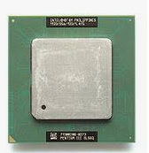

**EXPERIMENT 3**

**AIM : To study various connections and ports used in computer communication.**

* **VGA Port and its specification**
* **Serial port and its specification and applications**
* **Parallel ports and its specification**
* **USB port and its specification**
* **RJ45 connector**
* **Ethernet port**

**THEORY:**

1. VGA Port and its specification:

Short for Video Graphics Adapter or Video Graphics Array, VGA is a popular display standard developed by [IBM](https://www.computerhope.com/comp/ibm.htm) and introduced in [1987](https://www.computerhope.com/history/1987.htm). VGA provides 640 x 480 [resolution](https://www.computerhope.com/jargon/r/resoluti.htm) color display screens with a [refresh](https://www.computerhope.com/jargon/r/refresh.htm) rate of 60 [Hz](https://www.computerhope.com/jargon/h/hertz.htm) and 16 colors displayed at a time. If the resolution is lowered to 320 x 200, 256 colors are shown.VGA utilizes [analog](https://www.computerhope.com/jargon/a/analog.htm) signals, which means it is only capable of lower resolutions and lower quality display on screens.

The VGA connector is used for display devices and is used to connect a computer to a [monitor](https://www.computerhope.com/jargon/m/monitor.htm), [projector](https://www.computerhope.com/jargon/p/projecto.htm), or [TV](https://www.computerhope.com/jargon/t/tv.htm).A rectangle with two lines on the left and right side is a symbol used to represent the VGA connector on many computers and devices.

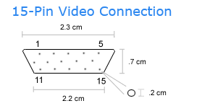 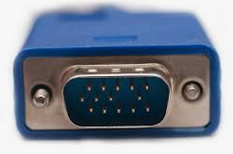

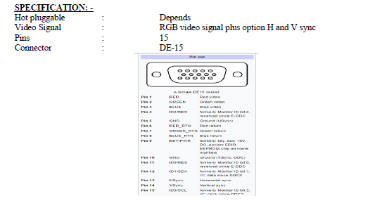

1. Serial port and its specification and applications:

A serial port is an interface that allows a PC to transmit or receive data one bit at a time. It is one of the oldest types of interfaces and at one time was commonly used to connect printers and external modems to a PC. Modern serial ports are used in scientific instruments, shop till systems such as cash registers and applications like industrial machinery systems.

Compared to a parallel port, the data transfer rate of a serial port is slower.

Normally, a serial port is a male port, while a parallel port is a female port. System resource configurations are chosen for each port and are identified by COM1, COM2, COM3, COM4, and so forth. Each COM position represents an input/output (I/O) and an interrupt request (IRQ) address. The I/O address transfers and receives data to and from a peripheral device such as a mouse or keyboard.

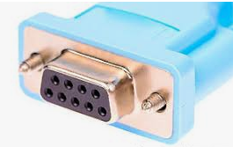

APPLICATIONS

Serial ports are very common on most types of microcontroller, where they can be used to communicate with a PC or other serial devices.

● Dial-up modems

● Configuration and management of networking equipment such as routers, switches, firewalls, load balancers

● GPS receivers (typically NMEA 0183 at 4,800 bit/s)

● Bar code scanners and other point of sale devices

● LED and LCD text displays

● Satellite phones, low-speed satellite modems and other satellite based transceiver devices

● Computer terminal, teletype

● Older digital cameras

● Networking (Macintosh AppleTalk using RS-422 at 230.4 kbit/s)

● Serial mouse

● Older GSM mobile phones

● IDE hard drive repair

1. Parallel ports and its specification:

A parallel port is an interface allowing a personal computer (PC) to transmit or receive data down multiple bundled cables to a peripheral device such as a printer. The most common parallel port is a printer port known as the Centronics port. A parallel port has multiple connectors and in theory allows data to be sent simultaneously down several cables at once. Later versions allow bi-directional communications. This technology is still used today for low-data-rate communications such as dot-matrix printing.  
  
The standard for the bi-directional version of a parallel port is the Institute of Electrical and Electronics Engineers (IEEE) 1284. This standard defined bi-directional parallel communication between computers and other peripheral devices allowiOriginally the parallel port was unidirectional and transmitted eight bits of data at a time down multiple strands of copper cable. It was introduced by CentronicsData Computer Corporation in 1970. The parallel port was designed to be used with printers and could transfer only a total of 300Kbits/secng data bits to be transmitted and received simultaneously.

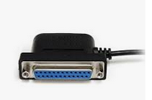

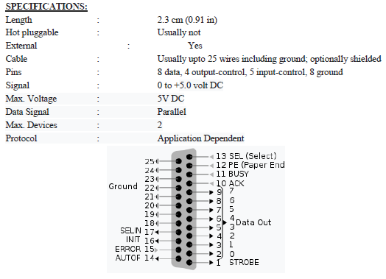

1. USB port and its specification:

A **USB port** is a standard cable connection interface for personal computers and consumer electronics devices. [USB stands for Universal Serial Bus](https://www.lifewire.com/universal-serial-bus-usb-2626039), an industry standard for short-distance digital data communications. USB ports allow USB devices to be connected to each other with and transfer digital data over USB cables. They can also supply electric power across the cable to devices that need it.

Both wired and wireless versions of the USB standard exist, although only the wired version involves USB ports and cables.

Several major types of physical layouts exist for USB ports:

* **USB-A (Type A)**: The rectangular [USB Type-A connector](https://www.lifewire.com/usb-type-a-connector-2626032) approximately 1.4 cm (9/16 in) length by 0.65 cm (1/4 in) height is typically used for wired mice and keyboards. USB sticks normally feature USB-A connectors also.
* **USB-B (Type B)**: Less common than type A, USB B devices are nearly square in shape and are commonly found on routers, computers, printers, and game consoles
* **Micro USB**: So-called Micro USB versions of both USB-A and USB-B also exist - smaller versions than their base counterparts, popular on mobile devices. Older but now obsolete "mini USB" versions can also be found on many old devices.
* **USB Type C**: With dimensions of 0.84 cm by 0.26cm, this newer standard is designed to replace both A and B with smaller ports to better support the thinner form factors of mobile devices.

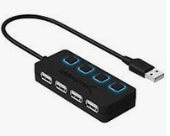

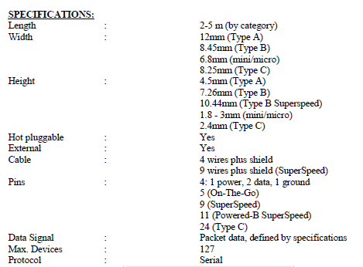

1. RJ45 connector:

Registered jack-45 (RJ45) refers to a cable termination specification that specifies physical male and female connectors and the pin assignments of wires-in telephone cables and other networks that use RJ45 connections.

RJ45 connections are also known as data jacks.

Registered jack-45 (RJ45) is an eight-wire connector used to connect computers on local area networks. They were initially used as a telephone-only standard, but have since been applied to high-speed modems and other computer networks.   
  
The RJ-45 is often confused with the 8P8C standard which looks almost identical but has particular properties regarding signal loss as the cabling is always made up of twisted pairs, a noise cancelling technology. The most common confusion is where RJ-45 is thought to be the same as an Ethernet connector, which is actually an RJ45S (or 8P8C) connection. RJ-45 is a telephony specification and although the connectors are almost identical to 8P8C, they have different signal conduction characteristics.   
  
The 8P8C standard connectors are commonly referred to as RJ-45S.

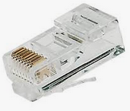

1. Ethernet port:

Ethernet connections are found on the back of a computer or the back or side of a laptop. A router may have several Ethernet ports to accommodate multiple wired devices on a network. The same is true for other network hardware like hubs and modems.

An Ethernet port accepts a cable that has an [RJ-45](https://www.lifewire.com/definition-of-rj45-817872) connector. The alternative to using such a cable with an Ethernet port is [Wi-Fi](https://www.lifewire.com/what-is-wi-fi-2377430), which eliminates the need for both the cable and the port.

An Ethernet port is a little wider than a phone jack. Because of this shape, it's impossible to neatly fit an Ethernet cable into a phone jack, which makes it a little easier when plugging in cables.

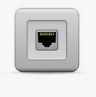

**EXPERIMENT 4**

**AIM : Simulation of following fundamental units on logisim simulator.**

**1.Half adder**

**2.Full adder and verification of its truth table.**

**THEORY:**

An adder is a [digital logic circuit](https://www.elprocus.com/different-types-of-digital-logic-circuits/" \t "https://www.elprocus.com/half-adder-and-full-adder/_blank) in electronics that implements addition of numbers. In many computers and other types of processors, adders are used to calculate addresses, similar operations and table indices in the ALU and also in other parts of the processors. These can be built for many numerical representations like excess-3 or binary coded decimal.

Adders are classified into two types: half adder and full adder.

The half adder circuit has two inputs: A and B, which add two input digits and generate a carry and sum.

The full adder circuit has three inputs: A and C, which add the three input numbers and generate a carry and sum.

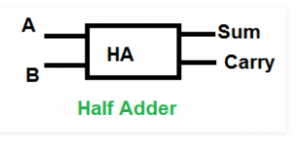 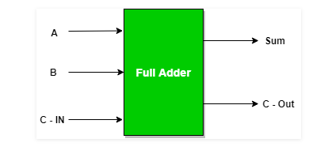

Logical Expression for Half Adder **Sum = A XOR B  
Carry = A AND B**

TRUTH TABLE OF HALF ADDER

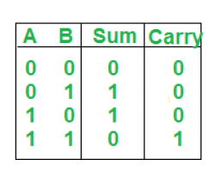

Logical Expression for Full Adder

SUM = C-IN XOR (A XOR B)

C-0UT=A B + B C-IN + A C-IN

TRUTH TABLE OF FULL ADDER

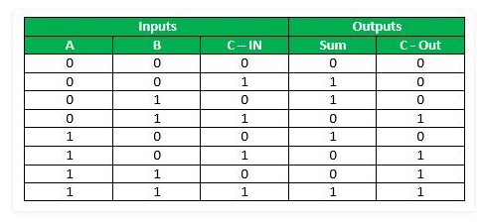

**IMPLEMENTATION USING LOGISM**

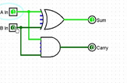 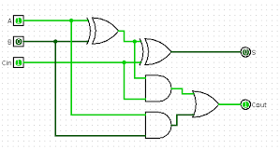

HALF ADDER FULL ADDER

**CONCLUSION:**

The truth table is verified.

**EXPERIMENT 5**

**AIM : Simulation on logisim simulator of Full adder using Half adder and verification of its truth table.**

**THEORY:**

Full Adder is the adder which adds three inputs and produces two outputs. The first two inputs are A and B and the third input is an input carry as C-IN. The output carry is designated as C-OUT and the normal output is designated as S which is SUM.  
A full adder logic is designed in such a manner that can take eight inputs together to create a byte-wide adder and cascade the carry bit from one adder to the another.

2 Half Adders and a OR gate is required to implement a Full Adder.

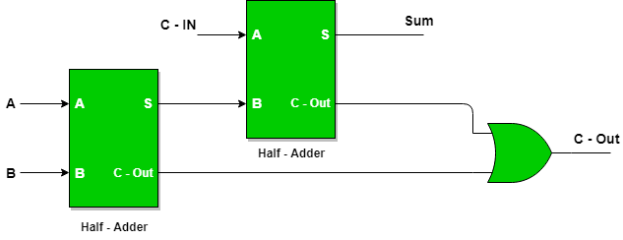

With this logic circuit, two bits can be added together, taking a carry from the next lower order of magnitude, and sending a carry to the next higher order of magnitude.

Logical Expression for Full Adder

SUM = C-IN XOR (A XOR B)

C-0UT=A B + B C-IN + A C-IN

TRUTH TABLE OF FULL ADDER



IMPLEMENTATION USING LOGISM

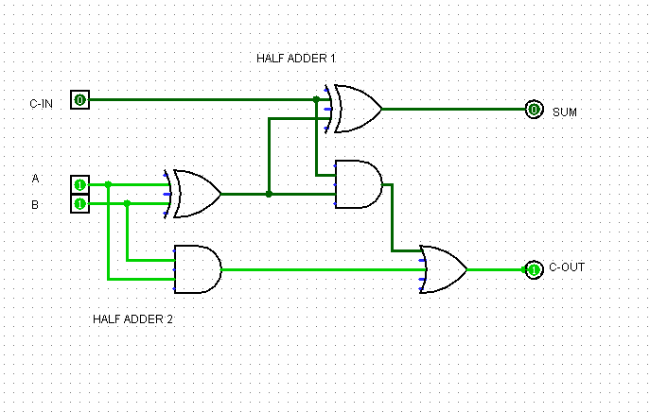

**CONCLUSION:**

The truth table is verified.

**EXPERIMENT 6**

**AIM :Simulation of 2 bit Binary incrementer using Half adder circuit and verification of its truth table.**

**THEORY:**

The increment micro-operation adds one binary value to the value of binary variables stored in a register. For instance, a 2-bit register has a binary value 10, when incremented by one the value becomes 11.

The increment micro-operation is best implemented by using two half adders. A 2-bit incrementer can be represented by the following block diagram.

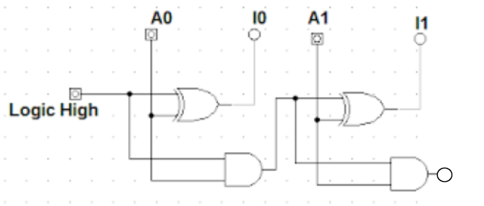

* Logic-1 is applied to one of the inputs of least significant half-adder, and the other input is connected to the least significant bit of the number to be incremented.
* The output carry from one half-adder is connected to one of the inputs of the next-higher-order half-adder.
* The binary incrementer circuit receives the two bits A0 and A1, adds one to it, and generates the incremented output in I0 ,I1.
* The output carry will be 1 only after incrementing binary 11.

TRUTH TABLE OF 2 BIT BINARY INCREMENTER

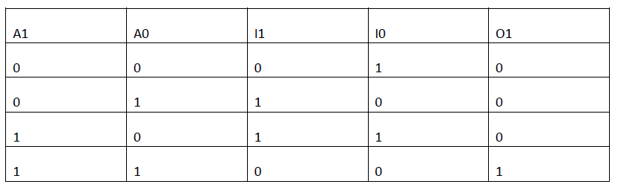

**IMPLEMENTATION USING LOGISM**

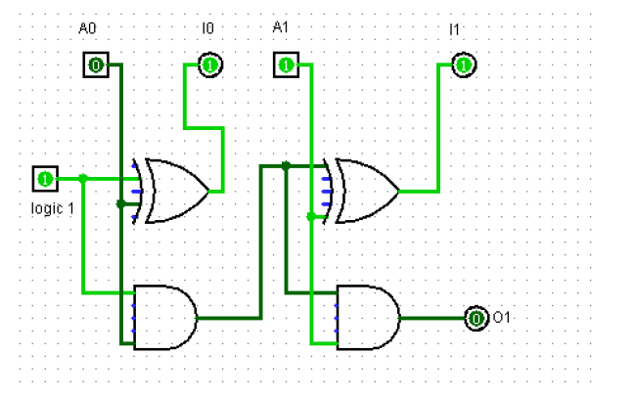

**CONCLUSION:**

The truth table is verified.

**EXPERIMENT 7**

**AIM :Simulation of 4x1 multiplexer and verification of its truth table on logisim simulator**

**THEORY:**

A **multiplexer** or mux is a combinational circuits that selects several analog or digital input signals and forwards the selected input into a single output line. A multiplexer of 2n inputs has n selected lines, are used to select which input line to send to the output.

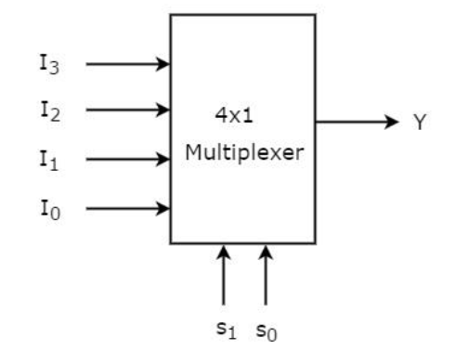 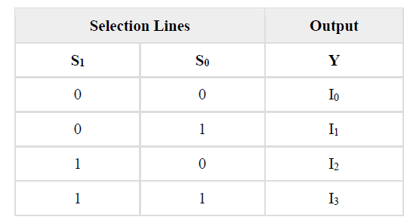

TRUTH TABLE OF 4 X 1 MUX

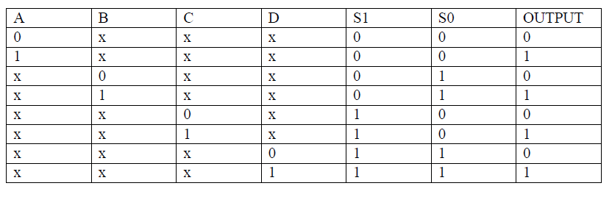

**IMPLEMENTATION USING LOGISM**

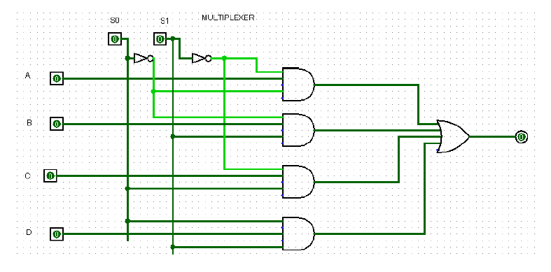

**CONCLUSION**:

The truth table is verified.